Title:
Assessment of Biochar Corn (Zea mays) Cob and Coconut Guinit as Media for Treating Public Market Wastewater

Names of Authors:
Arvin Rey L. Manalastas^{1,2}, Rosanilio M. Yagos^{1*}

Author(s) Affiliation
¹School of Graduate Studies, J.H Cerilles State College, Mati, San Miguel, Zamaboanga del Sur, Philippines
²Lamitan City Water District, Lamitan City, Basilan, Philippines

Email address:
rosanilioyagos@gmail.com

Assessment of Biochar Corn (Zea mays) Cob and Coconut Guinit as Media for Treating Public Market Wastewater

Juan M. Dela Cruz^{1,2}, John D. Snow^{1*}
¹School of Graduate Studies, J.H Cerilles State College, Mati, San Miguel, Zamaboanga del Sur, Philippines
²Lamitan City Water District, Lamitan City, Basilan, Philippines

*Corresponding author’s email: johnsnow@gmail.com

Abstract
The Abstract should not exceed 250 words, and it should contain a brief summary of findings and the conclusions of the study. Xxxxxxxxxxxx xxxxxxxxxxxxx xxxxxxxxxx xxxxxxxxxxxx xxxxxx xxxxxxxxxxxxxxxxxxx xxxxxxxxxxxxxx xxxxxxxxxxxxxxxxx xxxxxxxxx xxxxxxxxxx xxxxxxxx xxxxxxxxxxxxxxx xxxxxxxxxxx xxxxxxxx xxxxxxxxx xxxxxxxxxx xxxxxx xxxxxxxxx xxxxxxxxxxx xxxxxxxxxxxxxx xxxxxxxxxxxxxxxxx xxxxxxxxxxxxxxxxxx xxx xxxxxxxxx xxxxxxxxxxxx xxxxxxxxxxxxx xxxxxxxxxxxxx xxxxxxxxx xx xxxx xxxxxxxxx xxxxxxxxxx xxxxxxxxx xxxxxxxxxx. Xxxxxxxxxx xxxxxxxxxx xxxx xxxxxxxxxxxxxxxxx xxx xxxxxxxx xxxxxxxxxxx xxxxxxxxx xxxxxxxx xxxxxxxxxxxxx xxxxxxxxxxxxxxxxx xxxxxxxxxxxxxx xxxxxxxxxxxx

Keywords: aaaaaaaa, aaaaaaaa, aaaaaaaaa, aaaaaaaa, aaaaaa

Introduction
The author should give 2-3 paragraphs based on the type or category of information presented, with Motivation and aims of the study.

Material and methods
Please give an appropriate sub-heading for each of the categories, materials, or methods used.

Result and Discussion
Give an appropriate subheading based on the parameters you studied or findings. Author should be more focused on the justification of the results. Most important part of the discussion is the justification of own findings not comparing your findings to previous reports.

Table 1. Temperature and pH level result of the sampling stations
Station | Temperature (^{O}C | pH
Station 1 | 29 | 8.125
Station 2 | 29.16 | 8.14
Station 3 | 29.14 | 8.08

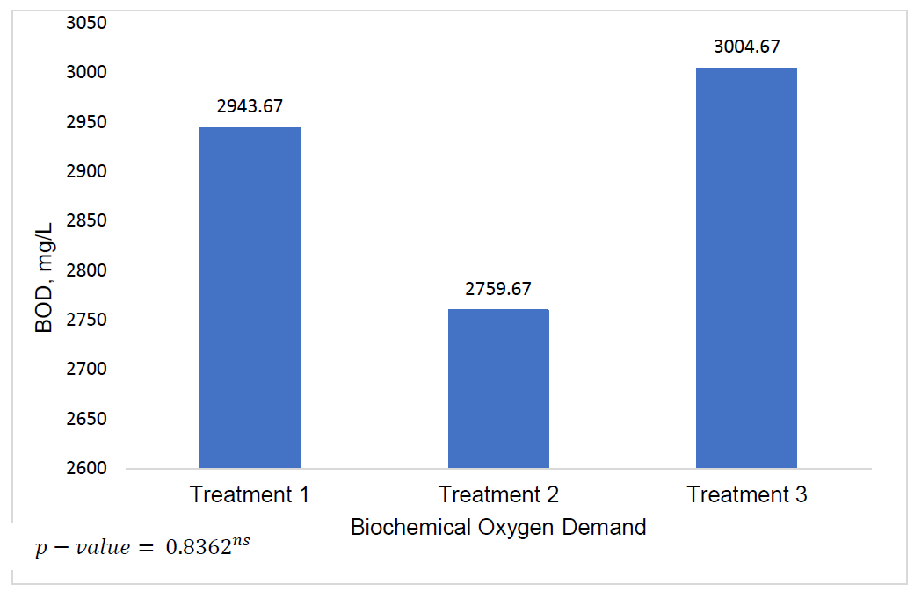
Figure 2. Analysis of Variance Result on Biological Oxygen Demand. ^{ns} – no significant difference

Conclusion
This section will also include the study's recommendations.

Acknowledgement

References
Reference must be accurate based on the Author Instructions of the journal(s)

